Skill: Historical Literacy
4 - Advanced | 3 - Proficient | 2 - Partially Proficient | 1 - Developing
In addition to proficiency, I can connect and synthesize ideas within an unfamiliar context. | I can accurately obtain and communicate historical information using all success criteria.  - Accurately applies ELO content | I can obtain and communicate historical information using some of the success criteria. | I attempt to obtain and communicate historical information.
ELO Specific Content: I can talk-to-the-text and summarize my highlighting into well written summaries.

Success Criteria  (*all are needed to achieve proficiency) | Feedback
Obtain  - / -- | - I talk to the text  - I create 1-2 questions about the information in the reading as I am reading (1-2 per section/article).  - I create one sentence summaries for each paragraph (possibly 2 paragraphs if they are short).
Communicate  - / -- | - I create a clear, concise and accurate summary of the reading  - My notes have clear and concise summaries of the material that I read (this is the overall content of the sentence summaries).

2. Political Developments in England
There were many reasons for the decline of feudalism in Europe. In one country, England, political developments during the 12th and 13th centuries helped to weaken feudalism. The story begins with King Henry II, who reigned from 1154 to 1189.
Henry II's Legal Reforms Henry made legal reform a central concern of his reign. For example, he insisted that a jury formally accuse a person of a serious crime. Cases were then tried before a royal judge. In theory, people could no longer simply be jailed or executed for no legal reason. There also had to be a court trial. These reforms strengthened the power of royal courts at the expense of feudal lords.
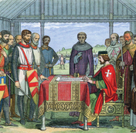
Henry's effort to strengthen royal authority led to a serious conflict with the Catholic Church. In the year 1164, Henry issued the Constitutions of Clarendon, a document that he said spelled out the king's traditional rights. Among them was the right to try clergy accused of serious crimes in royal courts, rather than in Church courts.
Henry's action led to a long, bitter quarrel with his friend, Thomas Becket, the archbishop of Canterbury. In 1170, four knights, perhaps seeking the king's favor, killed Becket in front of the main altar of Canterbury Cathedral. The cathedral and Becket's tomb soon became a popular destination for pilgrimages. In 1173, the Catholic Church proclaimed him a saint. Still, most of the Constitutions of Clarendon remained in force.

Summarize Henry II’s Legal Reforms:

King John and Magna Carta In 1199, Henry's youngest son, John, became king of England. John soon made powerful enemies by losing most of the lands the English had controlled in France. He also taxed his barons heavily and ignored their traditional rights, arresting opponents at will. In addition, John quarreled with the Catholic Church and collected large amounts of money from its properties.
In June 1215, angry nobles forced a meeting with King John in a meadow called Runnymede, beside the River Thames, outside of London. There, they insisted that John put his seal on a document called Magna Carta [Magna Carta: a written legal agreement signed in 1215 that limited the English monarch’s power] which means “Great Charter” in Latin.
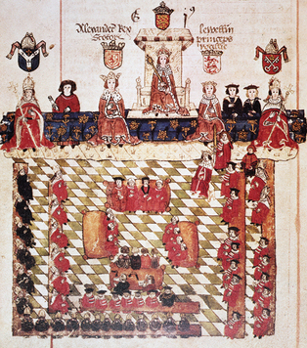
Magna Carta was an agreement between the nobles and the monarch. The nobles agreed that the monarch could continue to rule. For his part, King John agreed to observe common law and the traditional rights of the nobles and the Church. For example, he promised to consult the nobles and the Church archbishops and bishops before imposing special taxes. He also agreed that “no free man” could be jailed except by the lawful judgment of his peers or by the law of the land. This idea eventually developed into a key part of English common law known as habeas corpus [habeas corpus: the legal concept that an accused person cannot be jailed indefinitely without being charged with a crime] (HAY-be-us KOR-pus).

In many ways, Magna Carta only protected the rights and privileges of nobles. However, as time passed, the English people came to regard it as one of the foundations of their rights and liberties.

Summarize King John and Magna Carta:

King Edward I and the Model Parliament In 1295, Edward I, King John's grandson, took a major step toward including more people in government. Edward called together a governing body called the Model Parliament [Model Parliament: a governing body created by King Edward I that included some commoners, Church officials, and nobles] . It included commoners and lower-ranking clergy, as well as high-level Church officials and nobles.
Summarize King Edward I and the Model Parliament:

The Impact of Political Developments in England These political changes contributed to the decline of feudalism in two ways. Some of the changes strengthened royal authority at the expense of the nobles. Others weakened feudalism by eventually shifting some power to the common people.
Magna Carta established the idea of rights and liberties that even a monarch cannot violate. It also affirmed that monarchs should rule with the advice of the governed. Henry II's legal reforms strengthened English common law and the role of judges and juries. Finally, Edward I's Model Parliament gave a voice in government to common people, as well as to nobles. All these ideas formed the basis for the development of modern democratic institutions.
Summarize The Impact of Political Developments in England:

